**CS551 Advanced Software Engineering**

HOMEWORK 1

Sirisha Ayyagari

(ID= 16158369)

1. Design the Class Diagram/Sequence Diagram using Visio for the InClass Exercise.

Answer:

Below is the class diagram:

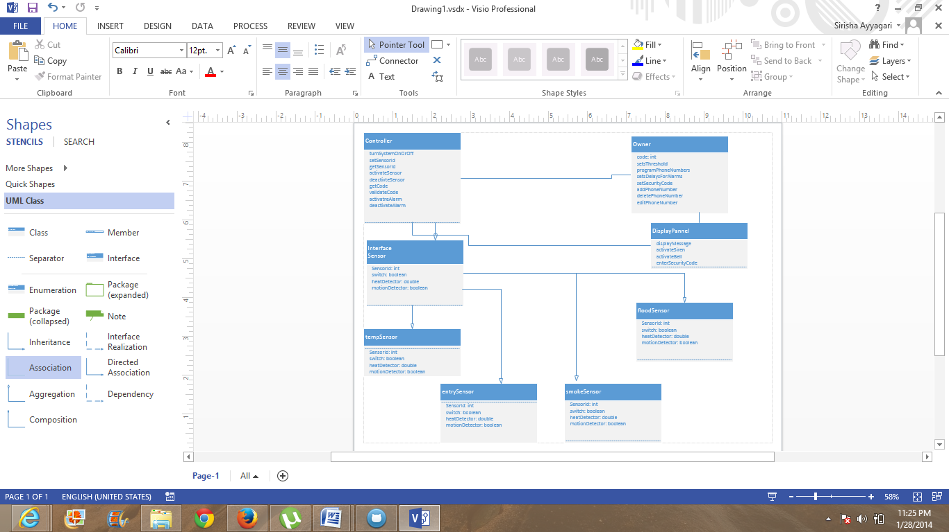

Below is the sequence Diagram:

3) Create a ScrumDo account and define task/plan/delivery for your lab 1 assignment. Also post your ScrumDo ID to the Lab 1 site.

Answer:

Below are the sequence of steps which explains the process of accessing the scrumDo.

* First, signup for scrumdo as below with username and password.

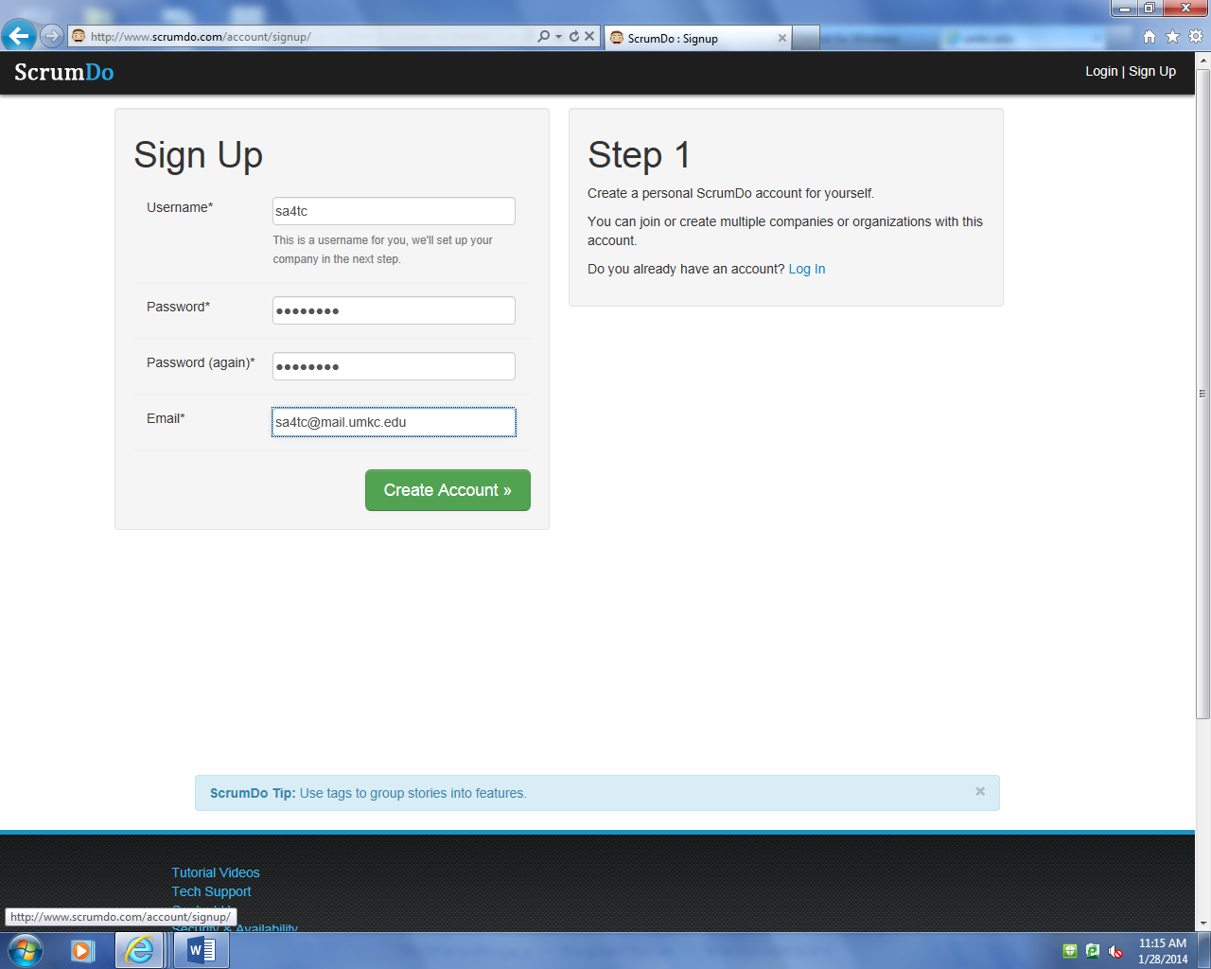

* It opens the homepage which displays like this and create a project:

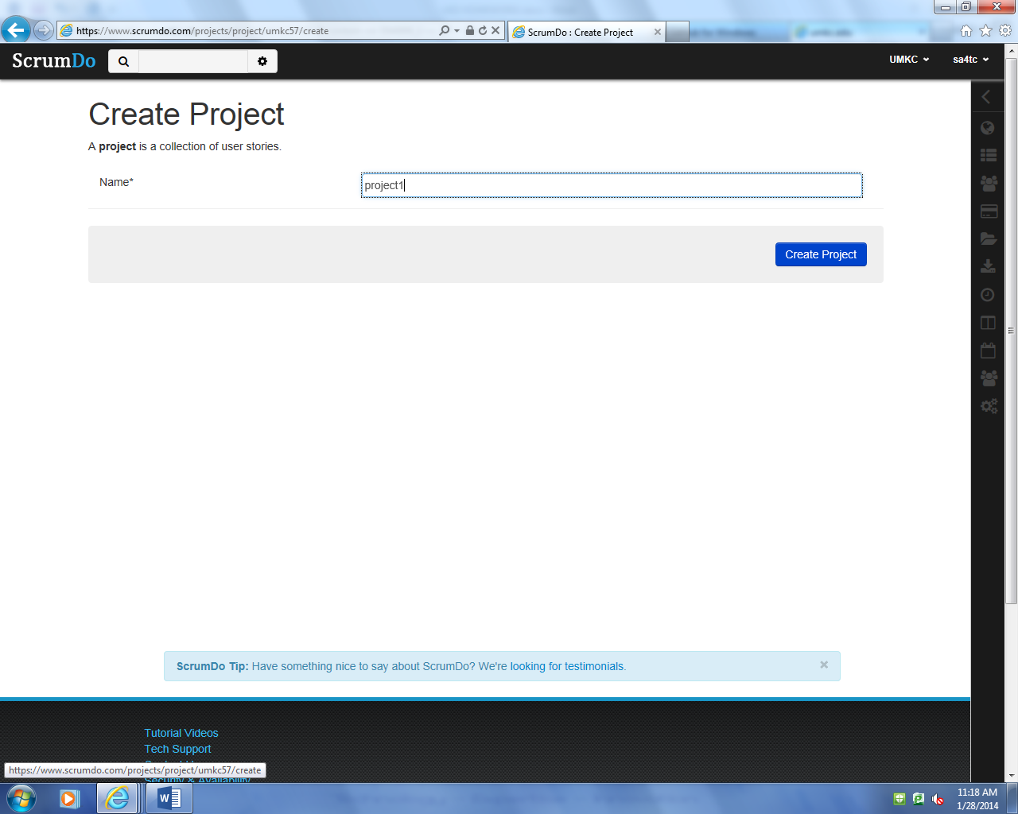

* As you did not create a story yet, there are 0 stories now. Then, add a story as below.

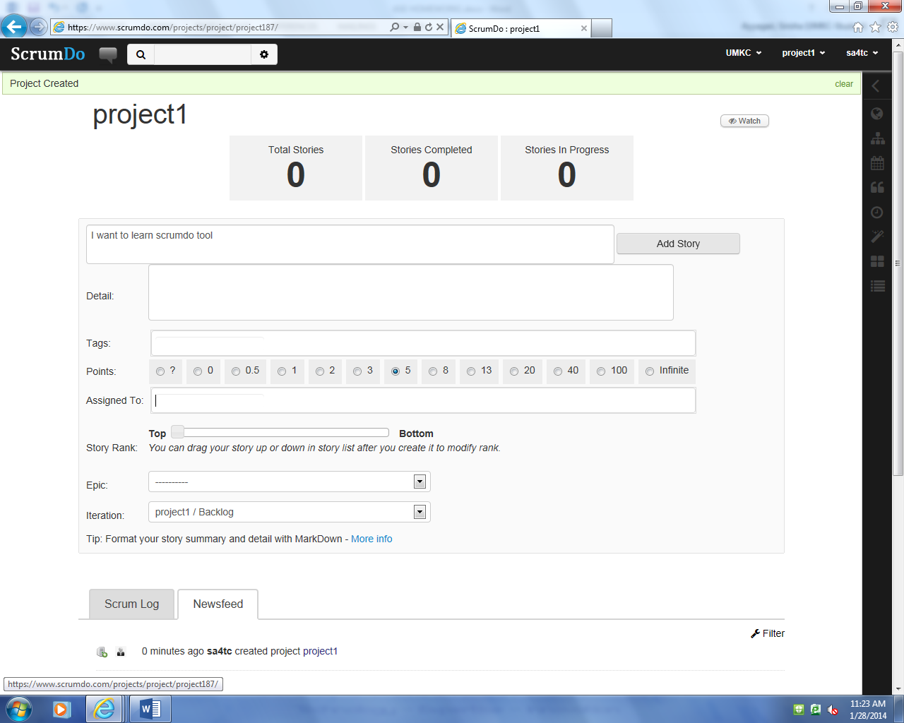

I created 2 stories, here below:

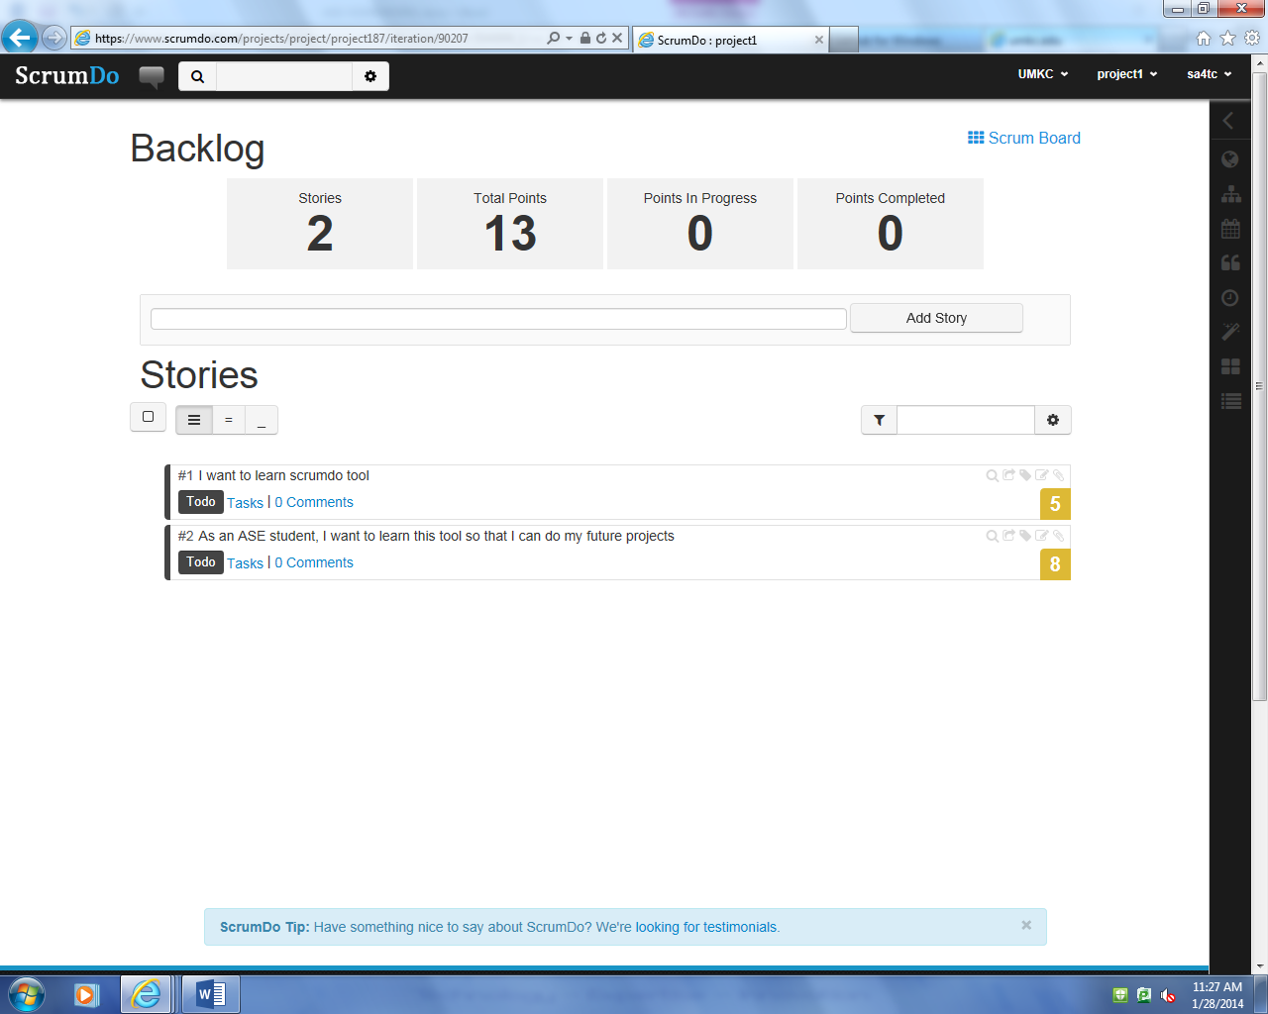

Add new iteration by clicking the project1 button in the top right corner.

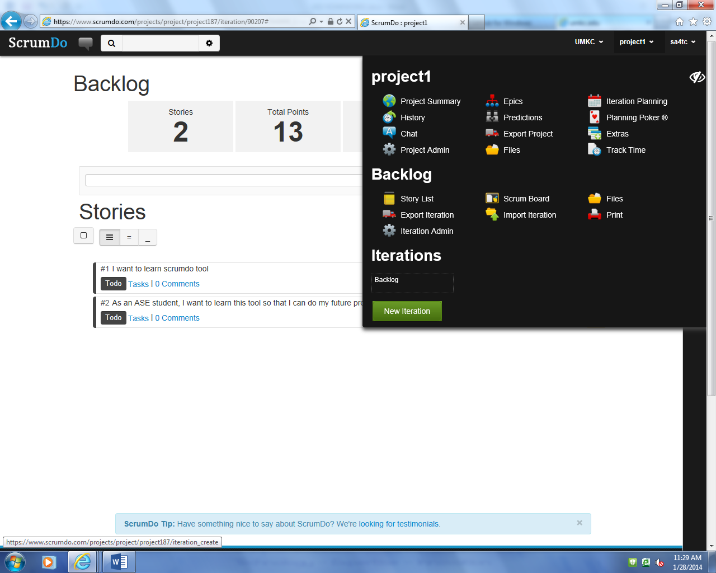

Write iteration name, start date and end date

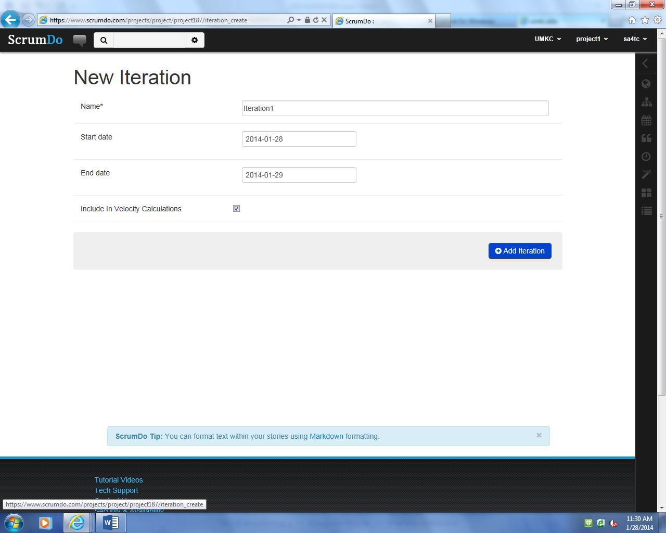

Select iteration planning

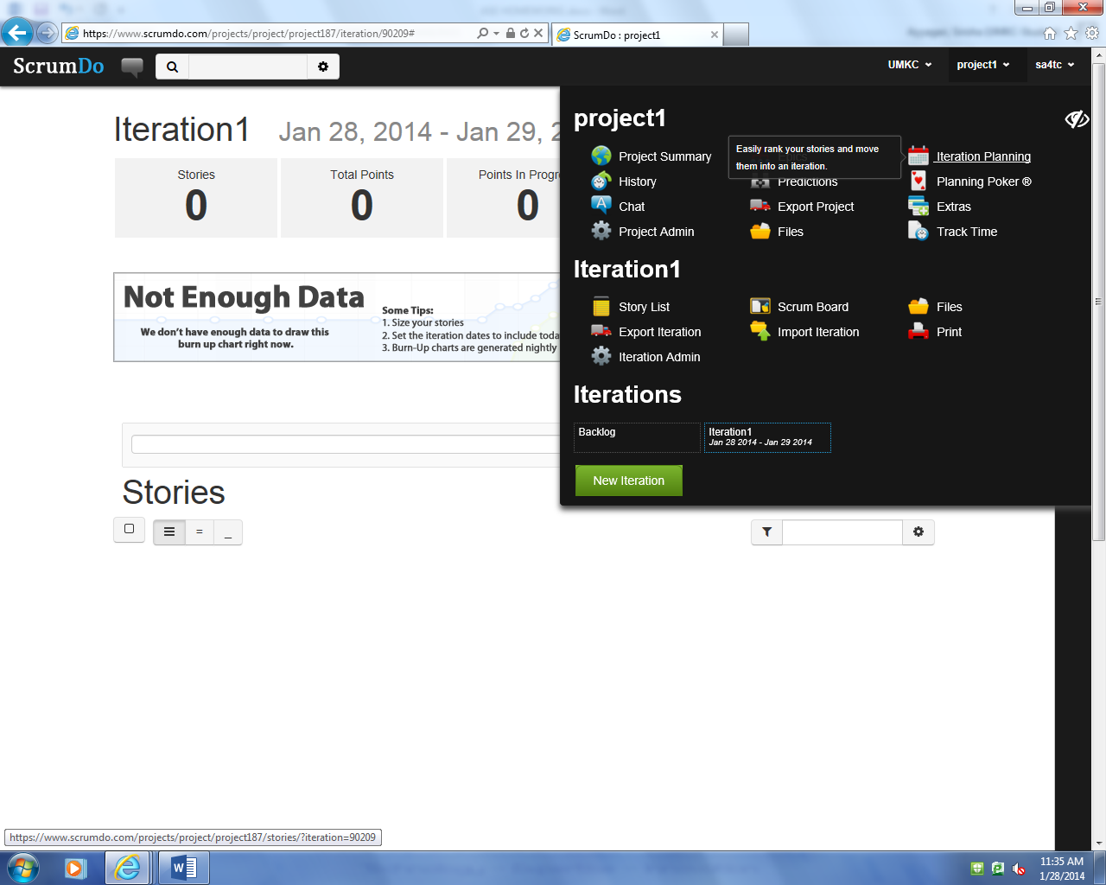

Backlog consists of set of newly creates iterations.

You can shift the iterations to keep it in iteration planning section from backlog section.

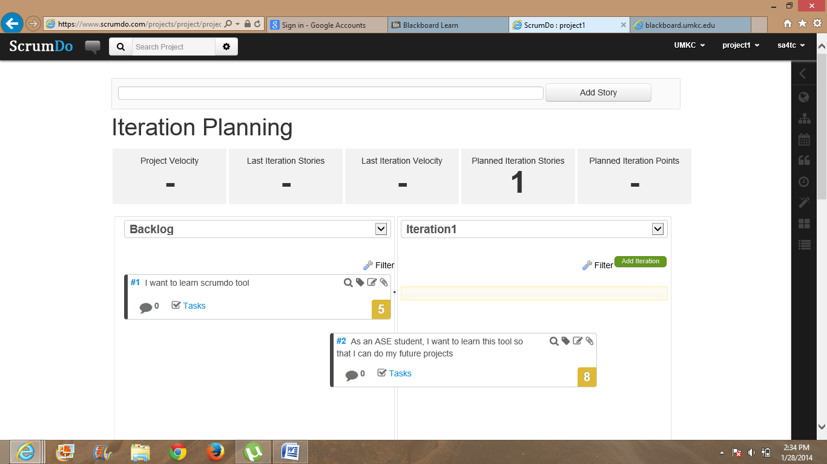

Now, select epics to add them

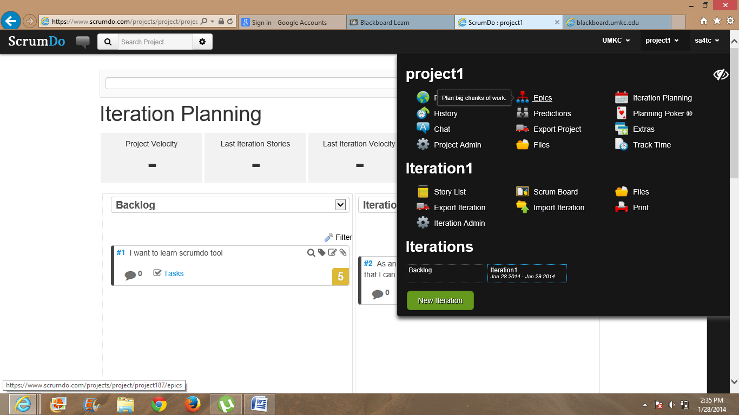

Create new epic

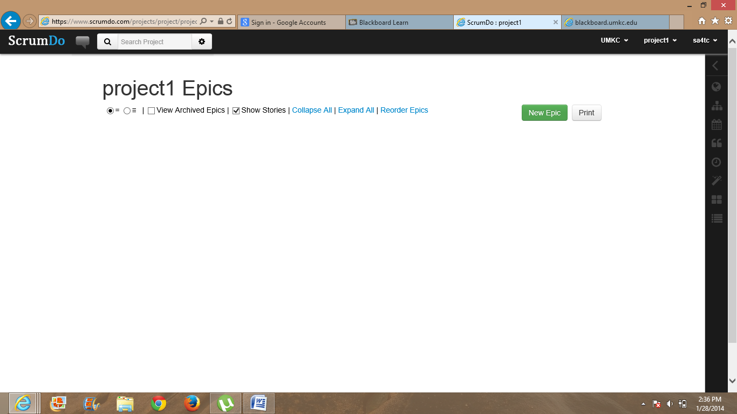

I have created epic1 and epic2 here

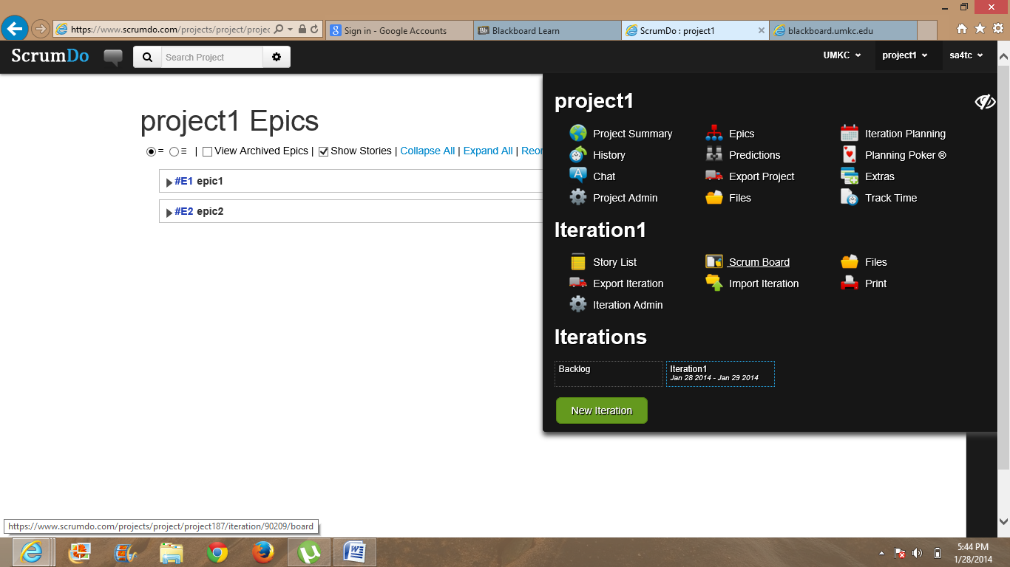

Now go to iterations created and place them where exactly they belong to. This screenshot shows that story created in iteration1 is switching from TODO to DOING.

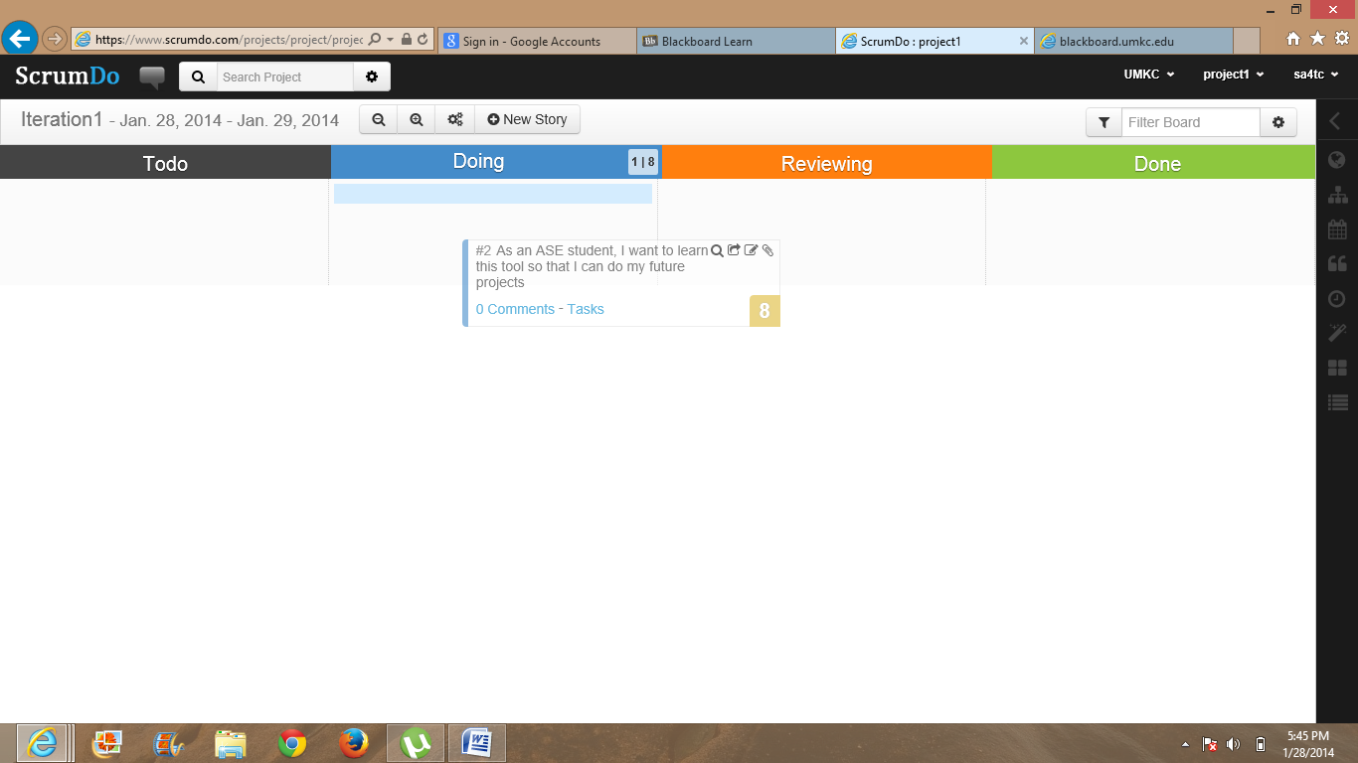

Now select teams to add team members

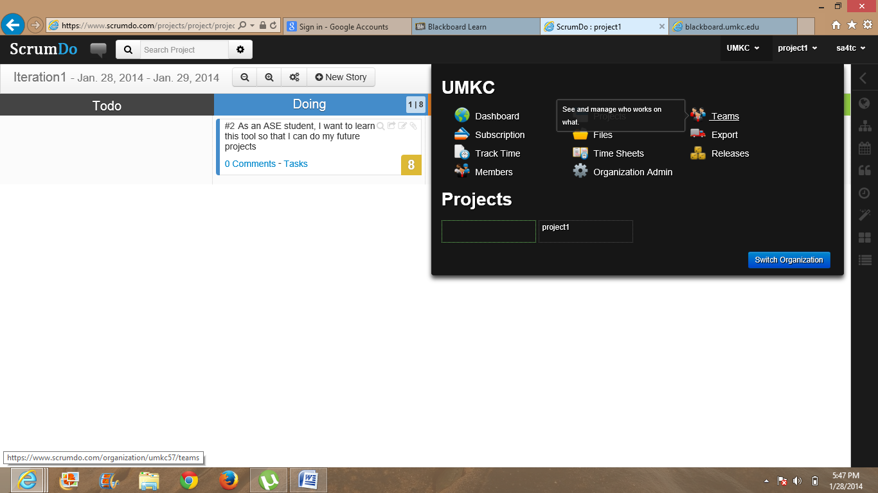

Adding AVANI to project1

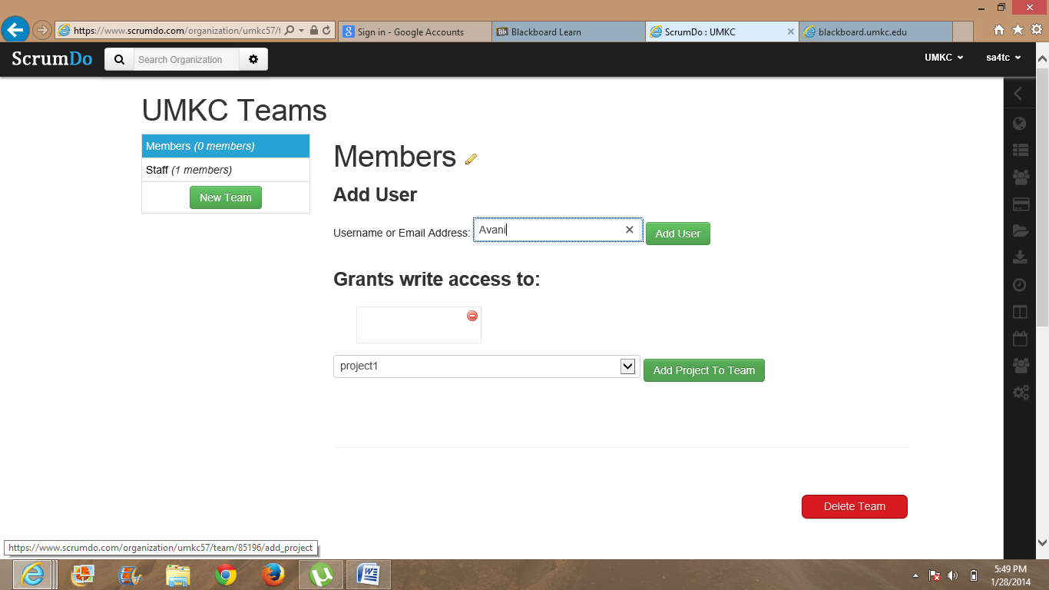

Below is the invitation which goes to team users you have created:

Hello,

Someone has just invited you to the ScrumDo team project1 in the UMKC organization. Please follow the link below to accept. http://www.scrumdo.com/organization/accept/xxxxx Thank you! The ScrumDo Staff

2. Create a GitHub account and post GitHub ID to the Lab 1 site

Answer:

Create a username and password in www.github.com

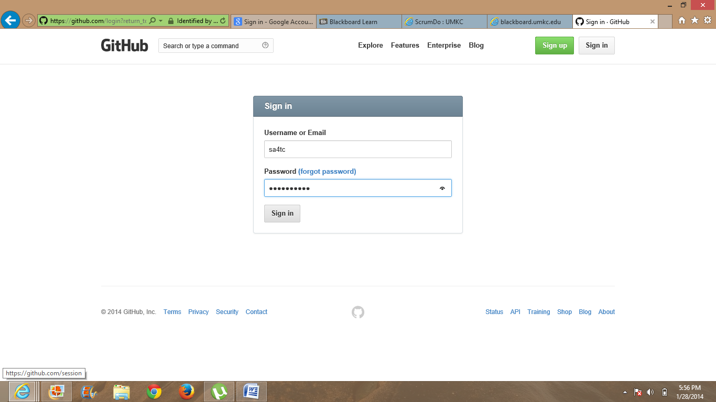

1. Create Git remote repository using Git account in web.

2. Install GitHub for windows, clone the remote repository to our local machine

3. Modify files at local machine, commit and synchronize with remote one.

Homepage looks like this

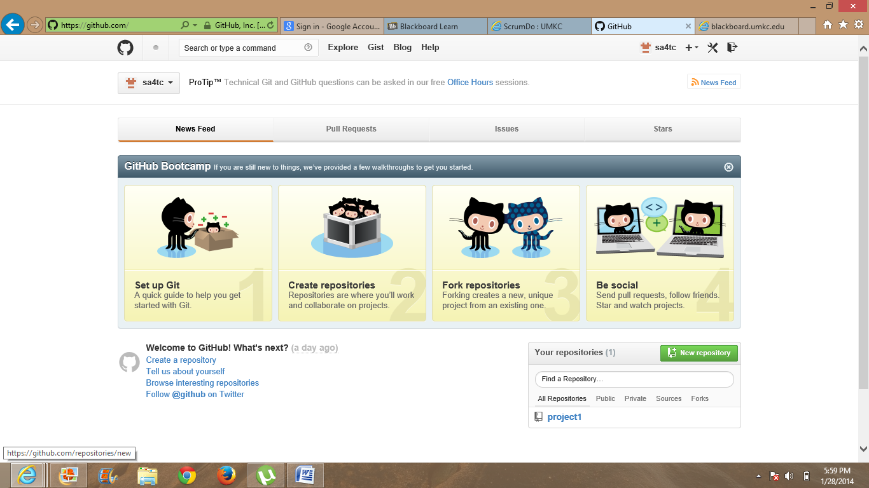

Create a repository

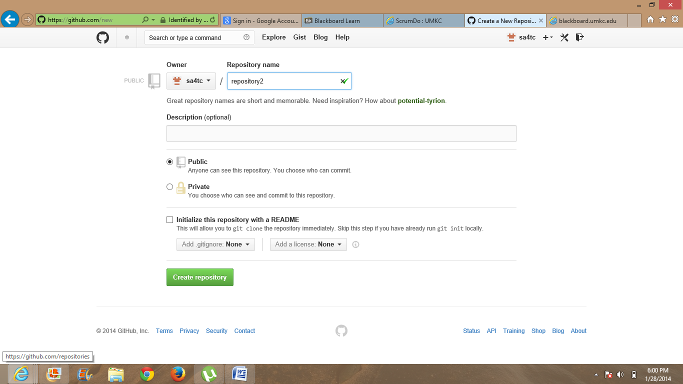

Click set up in desktop icon to get that repository in your local system

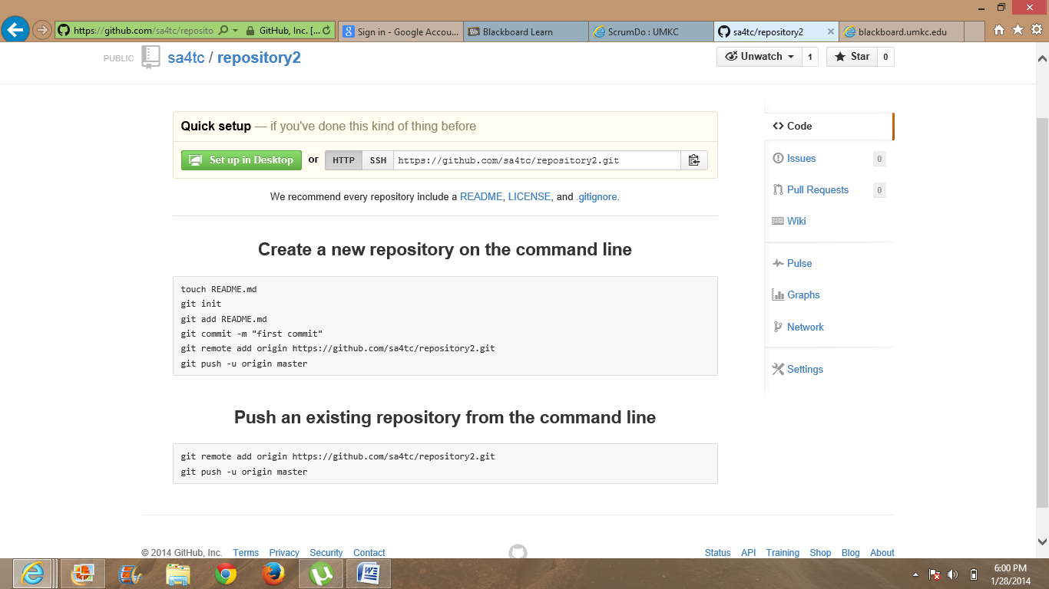

Signup into local github in your system

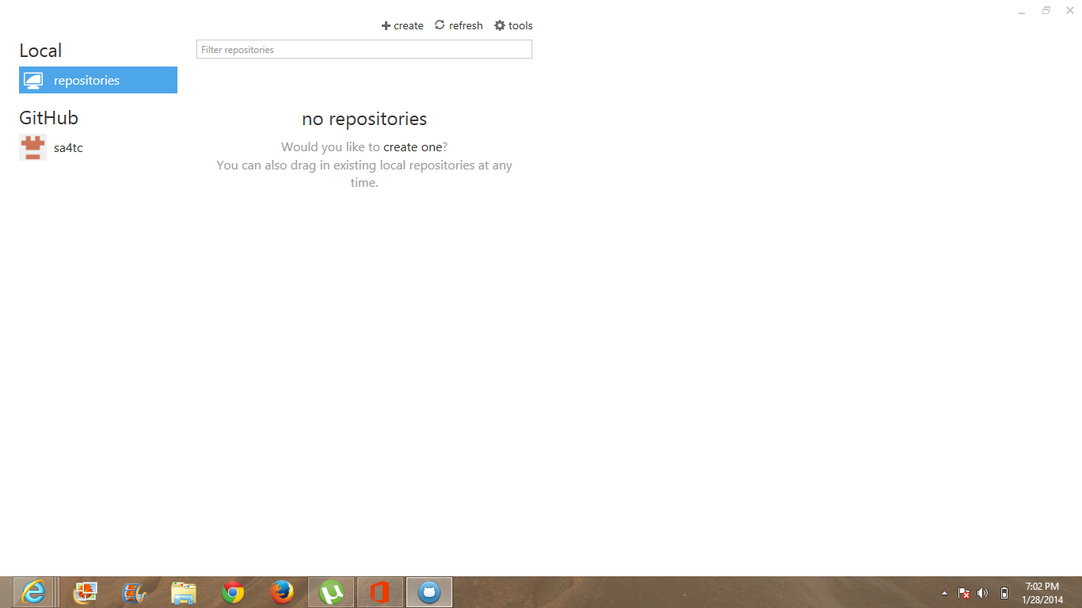

Create a new repository in local one

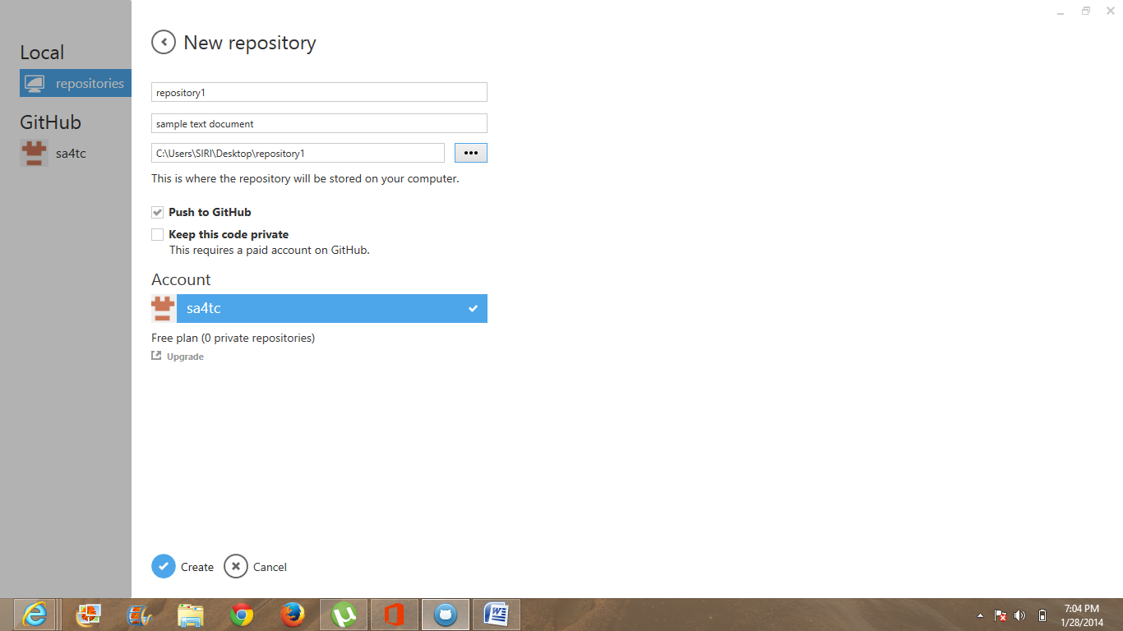

Adding text file into repository3 and commit it and sync it so that you get it in your remote account.

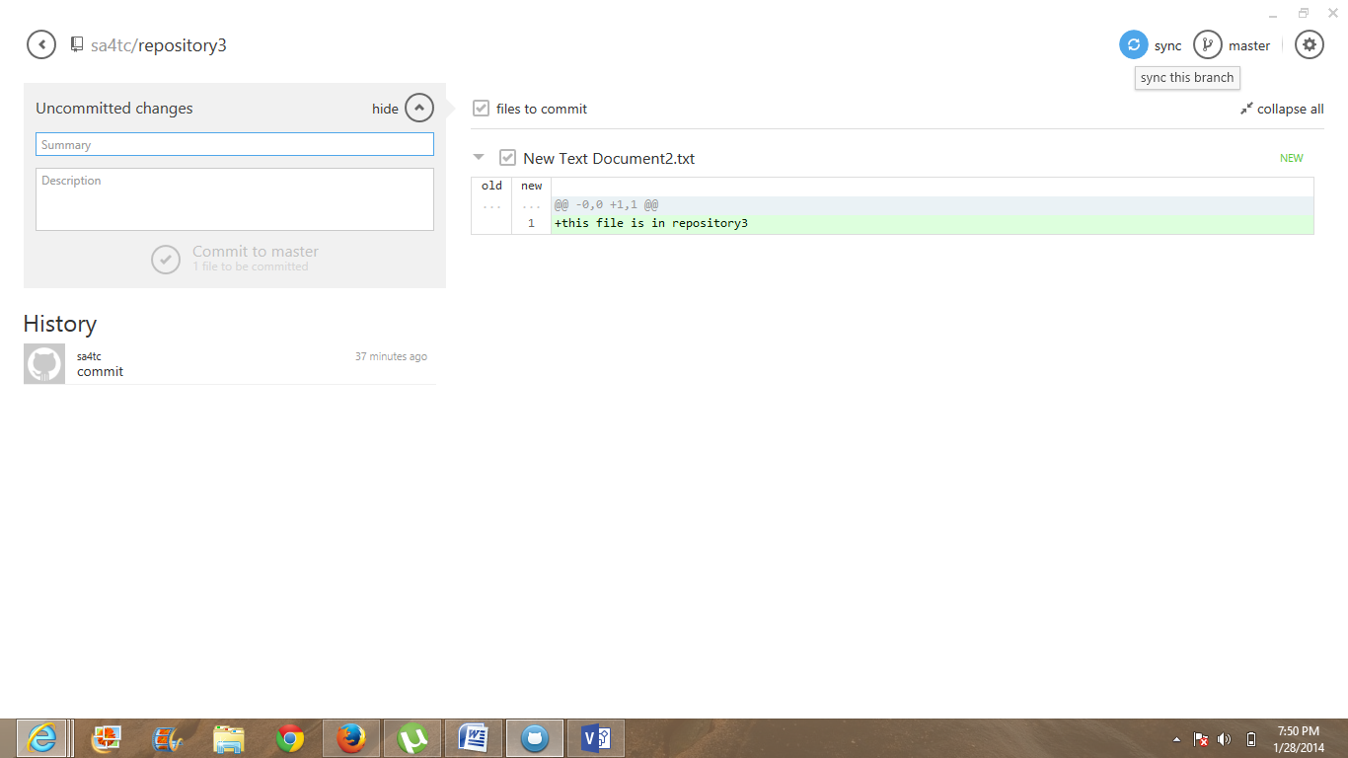

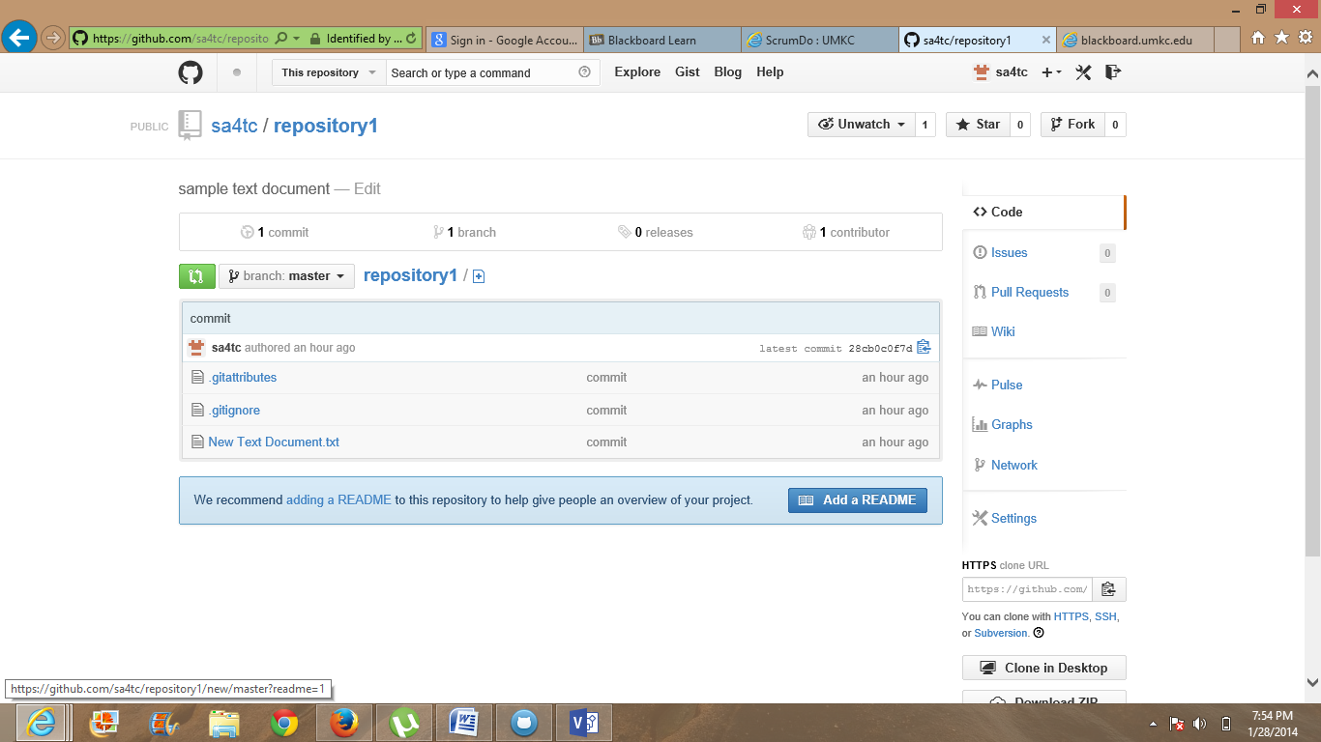

**Create a repository in web account and clone that so that you can get it in your local system**

**Below is modifying the remote repository in local system**

